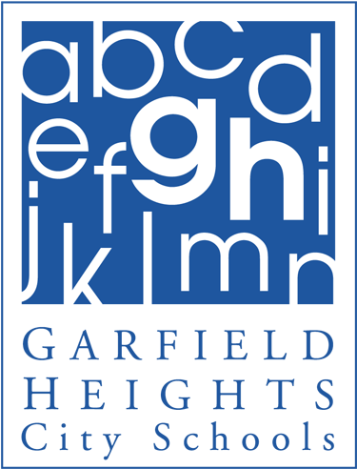 ***Elmwood Elementary School***

Principal Notes: April 1, 2014

Welcome Back! I hope everyone had a relaxing and enjoyable Spring Break. As we start back to school we are now in our final push for the 2013-2014 school year. Students will be starting fourth marking period! We will be sending Third Quarter Report Cards home on Friday, April 4th. With our crazy weather please make sure students are wearing proper clothing to and from school. Lastly, please make sure you log on to Progress Book and check your child’s grades.

Third, Fourth and Fifth grade students will be taking the OAA (Ohio Achievement Assessment) later this month. It is important students are present the day of testing. Students should have a good night’s rest before the test as well as a healthy breakfast. Please encourage our students to do their best the day of their tests! Listed below are the test days for April and May.

The Cleveland Indians Home Opener is Friday, April 4th.  We are encouraging students to wear their tribe gear or red and blue. Go Tribe!

No School on Friday, April 18th and Monday, April 21st for Easter Weekend.

***Important dates for the month of April :***

**Friday, April 4th: Cleveland Indians Day/Report Cards Sent home**

**Tuesday, April 15th: PTA Meeting 3:30 pm in the Cafeteria**

**Friday, April 18th and Monday April 21st:  No School Easter Weekend.**

**Tuesday, April 22nd: School Board Meeting @ 6:00pm at the High School**

***2014 OAA***

**Wednesday, April 23rd 5th Grade Reading OAA**

**Thursday, April 24th 4th Grade Reading OAA**

**Friday, April 25th 3rd Grade Reading OAA**

**Tuesday, April 29th 5th Grade Math OAA**

**Wednesday, April 30th 4th Grade Math OAA**

**Thursday, May 1st 3rd Grade Math OAA**

**Tuesday, May 6th 5th Grade Science OAA**

Go Bulldogs!

Gwen Abraham

**Terrance Olszewski**

Superintendent of Schools

**Allen D. Sluka**

Treasurer/CFO/Business Services

**Board of Education**

**Joseph M. Juby**

President

**Robert A. Dobies, Sr.**

Vice President

**June A. Geraci**

**Christine A. Kitson**

**Gary Wolske**



**Board of Education Offices**

5640 Briarcliff Drive

Garfield Heights, Ohio 44125

Telephone: 216.475.8100

Facsimile: 216.475.1824

www.garfieldheightscityschools.com