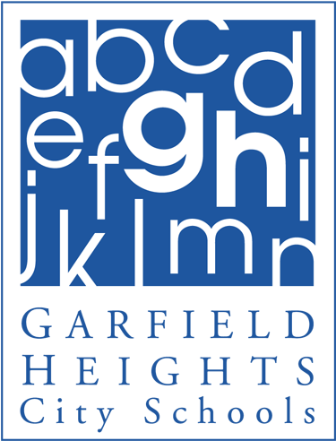 ***Elmwood Elementary School***

Principal Notes: January 9th, 2014

Happy New Year! I hope you had a truly enjoyable Winter Break and that you survived the “Winter Vortex”! Listed below are some important dates for the month of January.

Friday, January 17th will be Parent-Teacher Conferences. They will be held in the morning from 8:00-11:00am. The office will be contacting parents if a conference is necessary with a phone call. The third marking period will start on Tuesday, January 21st.

If school is closed due to inclement weather, the Board Office will be sending out a call with an important message. Please make sure to properly dress your child for the frigid temperatures during the winter months. Weather permitting, students will be going outdoors for recess. If you have not been receiving school or district phone calls, please be sure to update your contact information with the main office. Mrs. Wolske or Mrs. Studnicka will be happy to assist you!

***Listed below are the important dates for the month of January:***

January 15th - PTA meeting 6:30pm in the Cafeteria

January 15th - PICTURE RETAKE DAY!

January 16th - Last Day of the second marking period

January 17th - No School for students/

Parent-Teacher Conferences (8:00-11:00am)

January 20th - No School: Martin Luther King Day

January 21st - Start of the 3rd marking period

January 21st - Board Meeting at 5:00pm at the Board Office

.

Go Bulldogs!

Gwen Abraham

Principal

**Terrance Olszewski**

Superintendent of Schools

**Allen D. Sluka**

Treasurer/CFO/Business Services

**Board of Education**

**Joseph M. Juby**

President

**Robert A. Dobies, Sr.**

Vice President

**June A. Geraci**

**Christine A. Kitson**

**Gary Wolske**



**Board of Education Offices**

5640 Briarcliff Drive

Garfield Heights, Ohio 44125

Telephone: 216.475.8100

Facsimile: 216.475.1824

www.garfieldheightscityschools.com